

**Green University of Bangladesh**

**Department of Computer Science and Engineering (CSE)**

**Faculty of Sciences and Engineering**

**Semester: (Spring, Year:2021), B.Sc. in CSE (Day)**

**Course Title:**

**Course Code: CSE 202 Section: PC 202-D**

**Lab Project Name:** Bank Management System.

**Student Details**

|  |  |  |
| --- | --- | --- |
| **Name** | | **ID** |
| **1.** | Md. Adnan Abir | 202902035 |
| **2.** | Nura Anha Tamanna | 202902002 |
| **3.** | Mahede Hasan | 202902012 |

**Submission Date :** 08/09/2021

**Course Teacher’s Name :** Md. Solaiman Mia

**[For Teachers use only: Don’t Write Anything inside this box]**

|  |
| --- |
| **Lab Project Status**  **Marks: ………………………………… Signature: .....................**  **Comments: .............................................. Date: ..............................** |

**Table of Contents**

|  |  |  |
| --- | --- | --- |
| **No.** | **Topic** | **Page no.** |
|  | **ABSTRACT** | 02 |
| 1. | **Introduction** | 02 |
| 1.1 | Project Aims & Objective | 02 |
| 1.2 | Background of Project | 03 |
| 2 | **System Design** | 03 |
| 3 | **System Analysis** | 04 |
| 3.1 | Software Requirement specification | 04 |
| 3.2 | Existing VS Proposed | 05 |
| 4 | **System Implementation** | 05 |
| 4.1 | Screen Shots | 05 |
| 5 | **Future Scope & Conclusion** | 07 |
| 5.1 | Future Scope | 07 |
| 5.2 | Conclusion | 07 |
| 6 | **References** | 07 |

**ABSTRACT:**

A bank is a commercial or state institution that provides financial services, including issuing money in form of coins, banknotes or debit cards, receiving deposits of money, lending money and processing transactions. A commercial bank accepts deposits from customers and in turn makes loans based on those deposits. This project has many features which are generally not available in normal bank management system like the facility of client login and a facility of administrator login. It also has a facility for any bank authority who can monitor the whole system. It has also a facility where client and authority can see an account information by using this software.

**1. INTRODUCTION**

1.1 PROJECT AIMS AND OBJECTIVES

The project that we have undertaken aims to develop a banking system that is clean, user friendly and multi-functional. Development of this application includes a number of fields such that user feels comfortable and the system appears as dynamic to him. The aims and objectives are as follows:

* Transactions can be done with minimum user events.
* All transactional details and accounts are stored.
* Customers can view their own account details and can use them as necessary
* All customer’s data are stored safely.
* This system possesses is protected by administrative access.
* To provide flexibility for secure and save transaction for better performance.
* Reducing man power for doing work more accurately.
* Faster performance.

1.2 BACKGROUND OF PROJECT

Bank management system is an application which refers to calculation system which are generally small or medium in size. It is used by the bank authority to manage the whole system using a computerized system where authority can record various information of client and manage their account. The application will be extremely beneficial for the Customers intending to use and operate their bank account and will get various benefits in the field of management of accounts on a clean and user-friendly platform. “Bank Management System”, is a simple application, which is especially generated and designed for the bank in order to enter the applicant information about his or her bank account and can perform other function like currency change. With this computerized system there will be no loss of data record which generally happens when a non-computerized system is used. All these modules are able to help bank authority to maintain the transaction with more convenience and in a more efficient way as compared to those calculation systems which are not-computerized.

**2. SYSTEM DESIGN**

**LOG OUT**

**Deposit**

**Withdraw**

**search**

**Display All**

**Amount**

**Full Name**

**Account No**.

**Control**

**Panel**

**Customer**

**Details**

**Ask for Customer Number**

**Start Menu**

**3. SYSTEM ANALYSIS**

3.1. SOFTWARE REQUIREMENT SPECIFICATION

3.1.1. PRODUCT DESCRIPTION

The Bank Management System is an application for maintaining a person’s account in a bank. The system provides the access to the costumer to create an account, deposit/withdraw the cash from his account. The following documentation provides the specification of the system. We are mainly concerned with developing a banking system where a Customer can submit his/her deposit amount to bank if he/she has an account or can create a new account in this bank. Customer can also view the status and change currency of his/her bank account, can view account balance. One can easily maintain the above things if he/she has an account by login through his unique account number.

3.1.2. PROBLEM DESCRIPTION

* File lost
* Difficult to transfer money
* Difficult to calculate the interest
* Cost consuming
* Time consuming

3.1.3. SYSTEM OBJECTIVE

* Improvement in control and performance
* Save cost
* Save time

3.1.4. SOFTWARE REQUIREMNET

* Input customer total number
* Open an account
* View all account
* Search your account
* Update your fund details
* Withdraw money
* Deposit Money
* Exit
* Exit

3.1.5. HARDWARE REQUIREMENT

* Generally personal computer support java.
* Java Compiler.
* JDK

3.2 EXISTING VS PROPOSED SYSTEM

* Existing system does not have any digital and secure facility for client’s where proposed system will have facilities of many digital accounting systems which will save time as well as reduce errors.
* Existing system does not have any facility to generate all the particular information about the client’s information.

**4. SYSTEM IMPLEMENTATION**

4.1. SCREEN SHOT OF HOMEPAGE

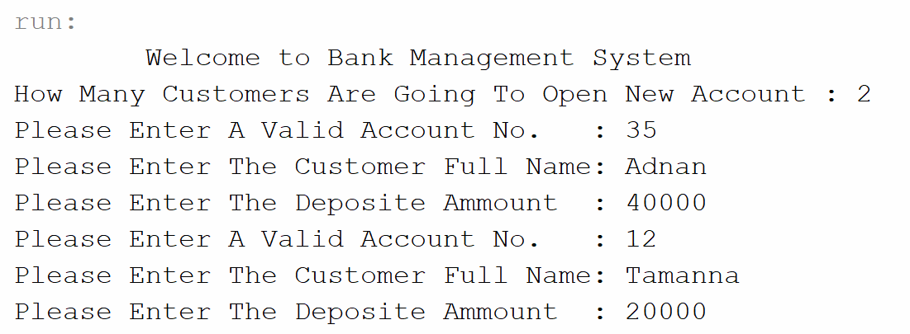

Fig 1: Entering Customers info

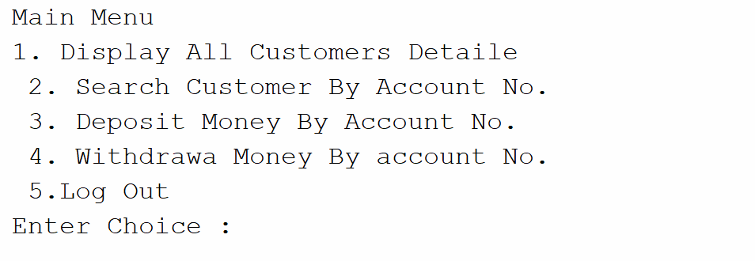

Fig 2: Main Menu

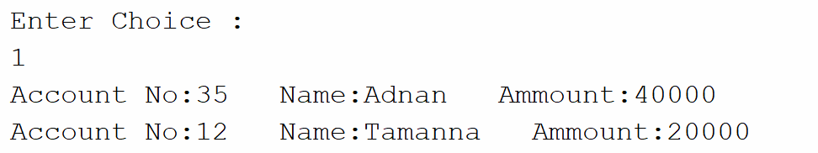

Fig 3: 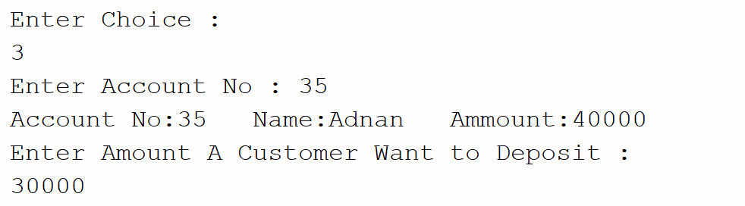All Customer info

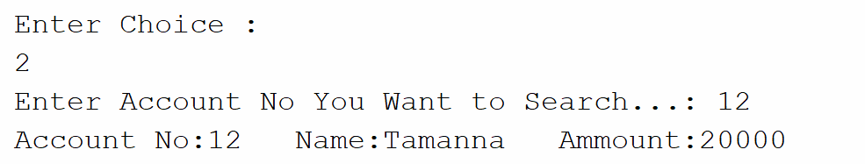Fig 4: Deposit Money

Fig 5: Search by Account No.

**5. FUTURE SCOPE AND CONCLUTION**

5.1. FUTURE SCOPE

This project was assign to us just a couple of weeks before the submission date. That’s why we haven’t got that much time for giving our full potential. So we have thought that, in future we will also set a log in panel for customers and admins. So that, it can be more secure and safe. Moreover, we will use java swing for making this software more attractive and user friendly.

Now, in long run it may be used in any good bank for improving their facilities and reduce many human errors. Lastly, this application can save a lot of times of customers which is so valuable.

5.2. CONCLUTION

We have successfully designed, develop and implemented this Bank Customers Management system which provides a more secured approach in managing bank customer’s information and strengthens the relationships between banks and their customers by providing the right solutions that uses a multi- level security to improve customer satisfaction. We therefore encourage other developers of similar application to think twice on how best they can improve in developing a more secured system that will meet the challenges we face today especially on the banking sector and other financial institutions.

**6. REFERENCES**

1. <https://visionarybusinessperson.com/bank-management/>

2. <https://www.javatpoint.com/object-and-class-in-java>

3. <https://www.slideshare.net/chsajiid/banking-management-system-project-documentation?from_m_app=android>

4. Lab class material’s provided by Md. Solaiman Mia, Assistant Professor, CSE Department of GUB.